### August 29th

### 12:11 AM]Kiran:

Dw, everyone should be assigned something on Wednesday

### [12:12 AM]Kiran:

Also I think we overestimated a lot for the time tasks will take

### [4:34 PM]Ben:

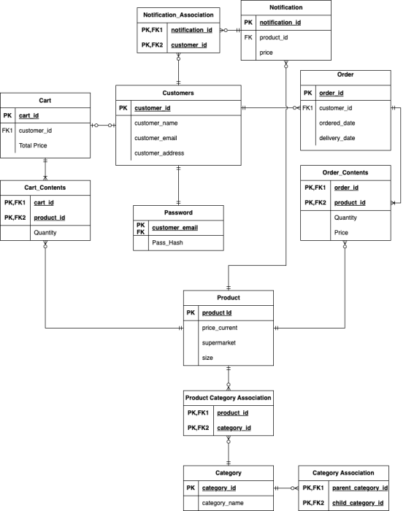

### [4:34 PM]Ben:

Created a data base schema

### [4:35 PM]Ben:

for sql database stuff

### [4:35 PM]Ben:

this has all the data bases connected is the only thing I think

### [4:35 PM]Ben:

and some stuff could be wrong

### September 4th

### [10:55 AM]Ben:

we will probably need to change the names of the folders from movies I think this means we also need to change the pom.xml to match whatever we change the folders to

### [11:13 AM]Ben:

I've just created a branch where I replace cinemas/movies with supermarkets/products

### [11:14 AM]Ben:

Idk if this is the correct formatting because I think it means that our whole application is called products

### [11:19 AM]Ben:

so let me know if you guys are happy with that file path because if so we can just merge it into main

### [1:42 PM]Ben:

Just another update because i'm not able to attend the meeting at 4pm but I've almost finished create delivery repository and I think it is mostly working I've just had trouble connecting the java stuff to the data base migration. I've created a branch off the new folder branch to add this stuff. I've also added some more of the general h2 console stuff into my branch which should probably be also added into main

### September 5th

### [5:49 PM]Ben:

I've just finished my first thing for the project and I've made some pretty big changes to the starter code that are probably useful for you guys too like H2 console and fly ways migration so I'm thinking I will merge both the file name branch and the branch with my changes into the main so that you guys have all the improvements i've made to the shared application

### September 10th

### [1:07 PM]Kiran:

@everyone just a reminder that we scheduled a meeting at 5pm today

### [1:07 PM]Tyler:

oh cheers i forgot about this one

### September 12th

### [3:42 PM]Tyler:

is our .gitignore setup properly?

### [3:52 PM]Ben:

Id hope so

### [5:01 PM]Tyler:

i have a bunch of .xml files that want to be committed but i dont think they should be

### September 13th

### [4:33 PM]Kiran:

@Jamie I added a search bar to the navbar aswell, but I haven’t pushed the changes yet

### [4:34 PM]Jamie:

lovely

### [4:36 PM]Jamie:

@Kiran dont forget to write something in the SRS about your design choices

### [4:42 PM]Kiran:

Yeah can do. Do I just say that it was in the wire fames?

### [6:37 PM]Jamie:

i mean i came up with a slight difference from the wireframe and then justified the change

### [8:34 PM]Kiran:

Ok sweet, I’ll try to do that

### September 14th

### 8:00 PM]Ben:

New updated diagram to match Dale's "suggestion"

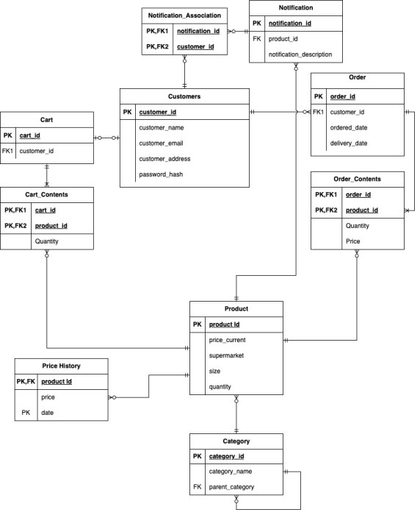

### [8:02 PM]Ben:

I will now update the schema to match in flyway

### [8:24 PM]Ben:

flyway updated

### [8:24 PM]Peter:

Oh no

### [10:42 PM]Ben:

Just a note the products CRUD stuff needs to be updated to include the supermarket attribute

### September 15th

### [11:20 AM]Kiran:

@everyone Just a reminder that we have a meeting at 12

### [12:12 PM]Peter:

@everyone where do we put our hours worked for the burndown

### 12:13 PM]Tyler:

oh yeah everyone has to put their hours on the excel sheet on teams

### [12:13 PM]Peter:

do we need the chart in the srs aswell?

### [12:13 PM]Peter:

for m2

### [12:13 PM]Kiran:

Probably

### [12:14 PM]Kiran:

Is anyone good with burndown charts?

### [12:18 PM]Andy:

@everyone added a statement of contribution for this milestone too in teams

### [12:20 PM]Andy:

sorry @Kiran i am not, but if you're still struggling with it tomorrow, give us a shout out

### [12:20 PM]Jamie:

added my contributions

### [12:59 PM]Kiran:

I’ll see how I go

### [1:33 PM]Ben:

@Andy I just merged my changes with Main this should fix the MVN test stuff

### [4:29 PM]Peter:

ive finished the checkout page and user profile page should i merge?

@Peter

ive finished the checkout page and user profile page should i merge?

### [4:39 PM]Jamie:

sure

### [9:42 PM]Jamie:

a document describing your CI with Multiple screenshots of failure and success . uh did any of us do continuous integration

### [9:42 PM]Andy:

ye it's a work in progress but im getting build errors lol

### [9:42 PM]Jamie:

i mean, thats fine

### [9:42 PM]Andy:

going to focus more on it tomorrow

### [9:43 PM]Jamie:

Documentation of test cases and evidence/documentation of test execution and results @Tyler dont forget to document tests in srs

### [10:01 PM]Tyler:

Yep ill get on that tomorrow

### [10:48 PM]Ben:

Okeydokey I have done the search functionality stuff which should all be working now the tests are a bit lapse but there is tests and they do pass so a win in my book

### September 16th

### [11:05 AM]Ben:

@Kiran I'm just going to add some stuff into the sprint retro I'll highlight it so you can see what ive added

### [11:22 AM]Kiran:

Awesome thanks Ben

### [11:23 AM]Kiran:

I haven’t finished the retro yet, so I can easily integrate what you add

### [1:53 PM]Kiran:

@Andy I’m not sure if we are meant to do this in this sprint. But last sprint we put the meeting minutes in the milestone1 folder. Do we have to do that for milestone2. I created the folder in git, so if it’s need it, would you mind putting it in the folder please

### [1:54 PM]Andy:

@Kiran yep can do

### [1:54 PM]Kiran:

Thanks

### [2:02 PM]Ben:

Also backend people i've put all the tests into the SRS with a short description which I have really rushed so if you get some time feel free to improve on the descriptions I have written for your tests but no worries if you can't

11:31 PM]Kiran**:**

Hey guys, I created a burndown chart. What do you think?

[11:31 PM]Kiran**:**

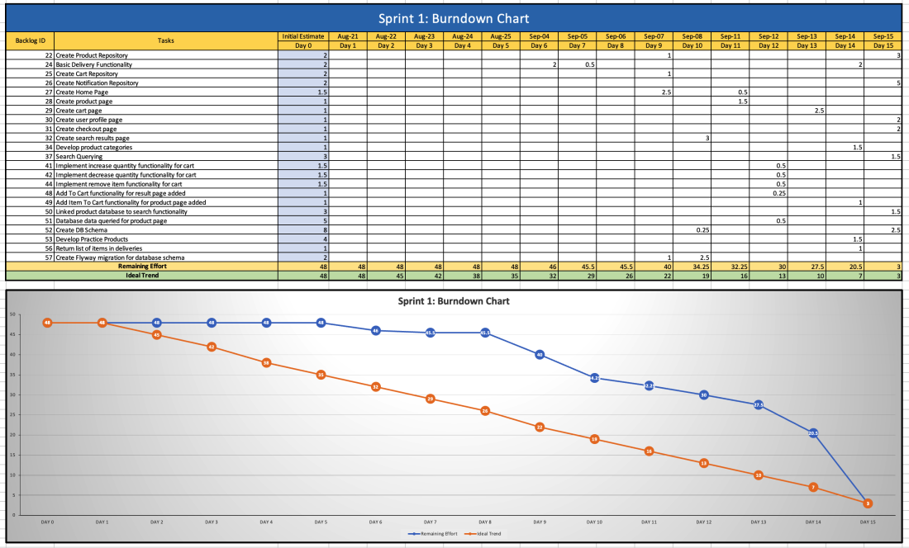

[11:32 PM]Ben**:**

Looks pretty good

[11:33 PM]Kiran**:**

sweet, ill add it to the SRS

[11:46 PM]Kiran**:**

@everyone I’m going to submit everything in its current state at 9pm tomorrow, including the copy of the SRS. So please try to finish everything before then. If not, let me know. Thanks

### September 17th

### [12:05 PM]Ben:

@Andy hows the CI going?

### [12:06 PM]Ben:

also im going to write a small paragraph about how we cannot yet to acceptance testing due to lack of functionality between front and backend does that work?

### [12:15 PM]Ben:

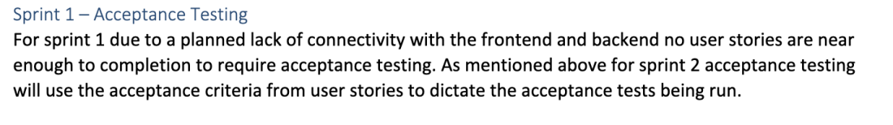

### [12:17 PM]Andy:

umm so i'm able to get the build for the backend but it's failing for the frontend atm, it says the problem is to do with npm test and i guess it's because we're lacking testing for frontend but i might just leave it out for now and just say frontend implementation is still in progress?

### [12:17 PM]Andy:

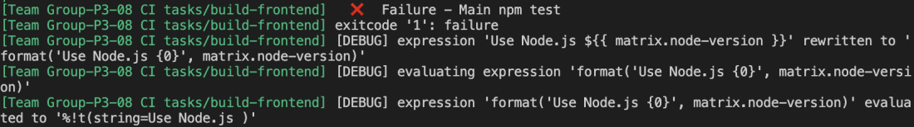

### [12:17 PM]Andy:

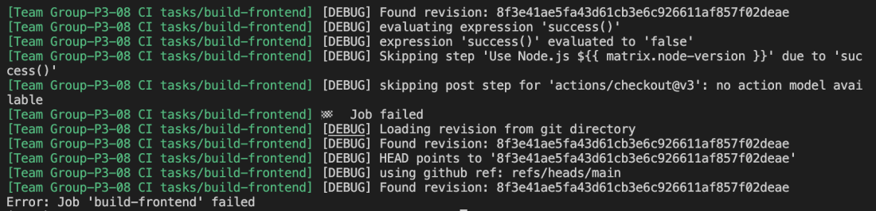

### [12:18 PM]Ben:

Yeah I thought that might have been the case

### [12:18 PM]Ben:

probably need to get some basic tests for the front end first thing next sprint